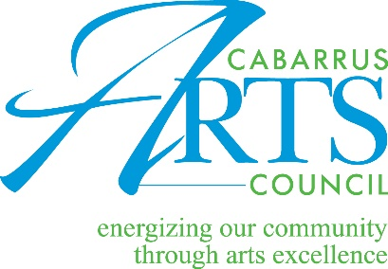

The Cabarrus Arts Council is committed to creating a diverse environment, proud to be an equal opportunity employer and welcomes a diverse pool of candidates in this search.

Administrative Assistant Job Description

The Cabarrus Arts Council is seeking a full-time Administrative Assistant. The position is a member of the support team, reports to the Operations Director and is an integral part of the arts council team. The Administrative Assistant provides administrative, clerical and customer service assistance to support the arts council operations. The Cabarrus Arts Council is a non-profit arts organization dedicated to providing a wide variety of diverse cultural programs and supporting the arts across Cabarrus County.

Duties include, but are not limited to: general clerical duties; serves as initial contact providing thorough knowledge of organization and programs to answer questions and promote the organization; answers telephones, emails, assesses and responds to inquiries; processing gallery and ticket sales; data entry and account maintenance in database and other business systems; office organization and maintenance; ordering and planning for office supplies and other product deliveries; prepares deposits and provides statistical reports; scheduling meetings and staff registrations for community events/meetings; creates in-house printed materials and email correspondence for publicity and notification; coordination of arts center calendar and communication of facility needs; meeting preparation and special event assistance

Minimum requirements:
- Excellent customer service skills
- Excellent organizational skills with attention to detail, multi-tasking and ability to prioritize
- Strong communication skills including written, oral and presentation
- Proficiency in MS Office Suite, particularly Excel, Word, Outlook, and the ability to learn new applications quickly
- Professional interpersonal skills and a positive attitude
- Proven ability to take direction but also to work with minimal direct supervision and manage multiple projects while being a committed team player.
- Ability to work well with volunteers, children and the public
- Comfort with people of diverse backgrounds
- Reliable means of transportation
- Available to work Monday-Friday 8:30 am-5:00 pm with some evenings and weekends for special events
- Interest in the arts, community engagement and inclusion
Working Conditions / Physical Requirements:
- This position requires frequent: standing, sitting for long periods, walking up to ½ mile, lifting, carrying, kneeling, crawling, pushing/pulling, balancing, bending, crouching, hearing, twisting, talking.
- Heavy lifting: Exerting over 40 pounds regularly

Hourly wage: $15
Benefits: Paid sick time, generous paid vacation and retirement match
To apply: Email a cover letter with resume and at least three professional references to Lisa@CabarrusArtsCouncil.org. Incomplete applications will not be considered. Applications will be evaluated in the order they are received. No phone calls.

