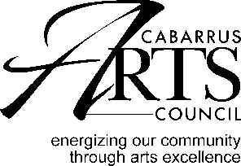 ARTS EDUCATION GRANT
GUIDELINES

Purpose
Arts Education Grants are available to pre-school, elementary, middle and high schools in Cabarrus County to bring artists into the school setting for a residency of at least 3 days. The purpose of the Arts Education Grants is to supplement school curriculum and to awaken students’ intellectual and creative curiosity. There must be a public component to these projects.
Deadline for application: August 14 at 4:00.

Eligibility
Public and private schools in Cabarrus County may apply for Arts Education Grants.

Program Timeline
Funded programs should be completed between July 1 and June 30 of the current year.

Matching Requirements
- Schools may apply for up to 50% of the cost of the program.
- Grant funds must be matched in cash. In-kind contributions may not be considered for matching purposes, but may be documented as additional evidence of support.

Funding Requirements
- Arts Education Grants may support artistic expenses directly related to the program.
- Allowable fees include artist fees, marketing, promotion, travel, contractual fees, rental of equipment and other program-related costs.
- Schools may apply for one arts council grant per year. It may include more than one residency.
- Arts Education Grants may not support programs that the school provides on a normal basis.
  - Activities that are concurrent with the project that are not arts-related
  - Food or beverages for hospitality or entertainment functions
  - Capital expenditures
  - Administrative or general operating costs

ARTS EDUCATION GRANT
GUIDELINES

Application Procedure
- Please email application and all attachments to: info@cabarrusartscouncil.org.
- Hand deliver one printed application and attachments to: Cabarrus Arts Council 65 Union Street South, Concord, NC

Schedule
Deadline for Emailed and printed applications: 4:00 pm on August 14.
This is not a postmark deadline.
Late or incomplete applications will not be accepted

May 15: Final reports are due no later than 4:00 on May 15.

When the dates fall on a weekend, the due date will be the following Monday.

