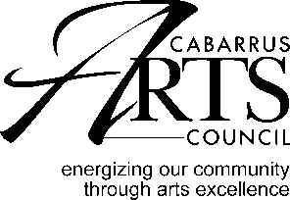 ORGANIZATION SUPPORT GRANT GUIDELINES
Purpose
Organization Support Grants are available to support local arts organizations in Cabarrus County. The purpose of this grant is to stabilize and strengthen arts organizations that provide high quality arts programming for the citizens of Cabarrus County.
Application deadline: August 14 at 4:00.

Eligibility
Organizations that meet the eligibility requirements below may apply for Organization Support Grants, however eligibility shall not guarantee funding.
An eligible organization:
- Is a private, non-profit arts organization classified by the Internal Revenue Service as 501(c)(3)
- Has a mission that focuses solely on the arts
- Is located in Cabarrus County and provides at least 75% of its programs and services in the county
.

Funding
- Organization Support Grants support general operating costs.
- Organizations that provide arts programs year-round may apply for up to 20% of their operational budget.
- Organizations may apply for one arts council grant per year.
Grant monies may not be used for:
- Capital expenses
- Dept reduction
- Food or beverages for hospitality
- Lobbying expenses

Composing the Narrative
In the application narrative, address the criteria below.
- Describe your organization
  - Mission
  - Board structure and diversity
  - Finances and fundraising
  - Commitment to diversity
- What is your outreach
  - The number and diversity of participants/members
  - The number of performances/other services
  - The number and diversity of audience members
- Artistic excellence
ORGANIZATION SUPPORT GRANT

Application Procedure
- Please email application and all attachments to: info@cabarrusartscouncil.org.
- Hand deliver one printed application and attachments to: Cabarrus Arts Council 65 Union Street South, Concord, NC

Schedule
Deadline for Emailed and printed applications: 4:00 pm on August 14.
This is not a postmark deadline.
Late or incomplete applications will not be accepted

May 15 Final reports are due no later than 4:00 on May 15.

When the dates fall on a weekend, the due date will be the following Monday.

