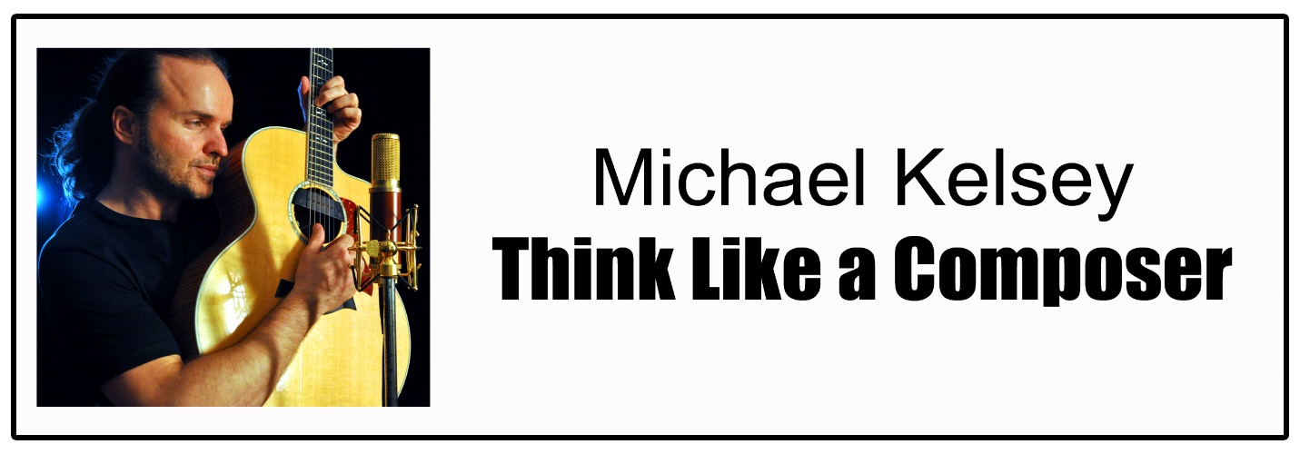
How do song writers put together a musical composition?
- Approach songwriting or music writing with an open mind.
Activity: Listen to several songs that you like.
What do you like about the composition?

Melody – is it a song where the melody sticks in your mind?
Lyrics – do you understand what the song is about and why it is a topic that someone might sing about?
Rhythm – does it have a good beat? Does it make you sway, tap your foot, or want to dance?
Emotion – how does the song make you feel?
If it makes you happy, are the words upbeat with music that makes you feel good?
If the song is about something sad, is the music moody and does it touch your heart?
If the song is angry, what would you expect the music to sound like?
If the song is about a nice day, what would you say and what melody would you use?

- Think about the instrument that is playing the song. Let’s say it is a guitar.
  - The first thing a guitar player might do is strum a chord across the strings. This is a simple way of playing the instrument. What else might be done?
Playing one string at a time.
Finger-style picking
Pulling the strings
Playing like a drum on the sound box

  - When we look beyond the simplest way to play an instrument and begin to look at all the possibilities, we begin to realize that instruments are capable of adding a great deal of interest to our composition. When we think about a guitar, it has many voices. We bring out those expressions by listening to the sounds of the instrument as we try different things with it.
    - We can play one string and have a simple melody
    - We can strum a chord and sing a melody
    - We can give the instrument more voices by making sounds on the guitar that express emotion
    - We can make the guitar sound like more than one instrument by playing different parts of it.
    - We can create many moods with music by the sounds we choose to create.
    - We can play the guitar in a way that expresses an emotion.

- You want to write a song, but you aren’t sure what to write about.
Where can you find ideas?
  - Start by looking around where you are. Look for an object, like a ball, a sock, a person.
  - How would you describe that object or person?
Shape
Color
Size
Location
Is there anything different or unusual?
How would it be used?
If it is a person, what are they wearing? How does the person look?
If you thought about this object or person in relation to something else, what would you say? For instance, does the ball remind you of the earth? Could you imagine what to do with a ball in a swimming pool?
If you could use your imagination and pretend that the object is something else, what would it be? If you could imagine the person somewhere else, where would they be?

- Make up a little phrase about that object or person, and make up a little song melody to go with it. This is the first musical expression you have about your topic. You can write lyrics anywhere. Put them on a napkin; make notes on your cell phone’s memo pad; make a recording on your phone; keep a little note pad and pencil in your pocket; or just figure out a way to remember them. Many songs have lyrics that rhyme, but they don’t have to. They do have to be able to be used with some sort of beat or rhythm. If your lyrics don’t work to the beat you want, then you may need to re-write them later, or change the beat.

- Add some more thoughts in the form of lyrics and some more melody until you have strung together several musical expressions. This is the first step in composition. There are so many ways to tell your ideas through music. Try to think of several ways you might write the lyrics. Do the words you chose express your emotions? Keep working on it. Come up with a second or a third melody for your song. See which one best expresses what you feel.

- Think about how you feel about your song. Are you feeling happy or sad about the subject? What kind of sounds might best demonstrate what you are feeling? If you were to play some musical chords on the guitar would you want them to express joy or sorrow or something in between?

- Now think about the rhythm of the song. Do you want the song to be peppy and full or life, or is the mood you want more mellow and reflective? Do you want to sing a song you can dance to or is your topic more about feelings? What kind of pace would you give to your song.

- After a composer has the rhythm, melody and lyrics for his song, finding more ways to use sound to express the emotions you feel in the song will add color and expression to your composition.
Look for harmony that can enhance the sound.
Add different, or more complicated chords to play.
Add extra notes that give more emotional expression.
Add more complex rhythms or percussion beats that add emphasis.
Add more instruments for different sounds and textures.
Add more voices that give the sound range and depth.
Use your own voice in a different and interesting way.
Is there a special phrase in the song that you like that you would like to repeat more than once? Is it easy to say, easy to remember? This could become your chorus, or hook as it is called in music, that helps the message of your song sink in deeper for listeners. People love to sing along with a short chorus that they can remember.

- When we make a composition, we are using sound and time arranged the way we like it to make a song that conveys a message with emotion, color and rhythm.
(10) Music is infinite. There is no limit to how many ways we can combine sound vibrations, rhythms and emotions to express ourselves. Music belongs to everyone! Every individual can make music and to enjoy it!

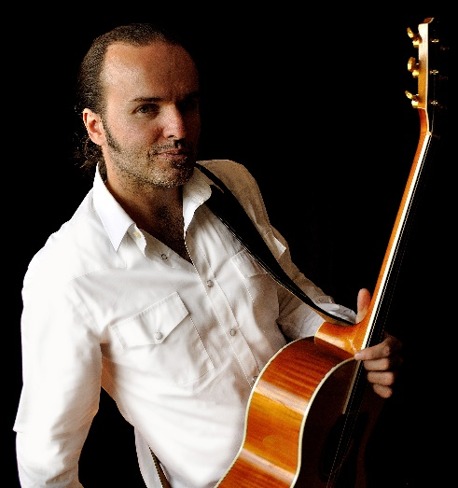
A Note from Michael
I was always fascinated with making music, playing in a band, writing songs, the whole process intrigued me.
When I was 8 years old, I had a Cub Scout book that had a chapter on how to make instruments from household items. To me, there was no difference between a real guitar from the store or a cigar box with kite string stretched across a piece of wood for a guitar neck. A group of bottles filled with different levels of water was the same to me as an actual xylophone. They were tools to make sound.
I would make up little compositions with my friends. It felt powerful to create something from scratch. Writing was fun. Then, performing music was another aspect that was exciting. I drew me out, and I really enjoyed it. To this day, I have that same excitement of thinking, "Hmmm. What could I do to make this moment special for all of us?" at every live performance.
I took some formal guitar lessons at age ten. My teacher made it fun for me. There was nothing technical about how he taught. Having fun playing riffs from songs I loved made me practice more, and, by practicing harder, the technical stuff fell into place in its own time and made more sense to me.
I was a very quiet kid growing up but with music I felt comfortable. Throughout my life it has connected me with people I would have never met. It put me in happy situations I would have never been in, and it took me to places I might never have visited.
Music is a way of life for me. There is no separation. I am always experimenting with sound. We all have a part of us that finds a voice through music. I like showing others how to tap into that inner musician and express themselves through sound.
9-20-2017

